
ART CONTEST!

Help us create a design to decorate the new Little Free Library in Lippitt Park! We welcome design entries from all Summit Neighborhood kids, ages eighteen and under.
1st Prize:
YOUR design on the library box and a $25 art supply gift certificate
2nd Prize:
$15 art supply gift certificate
3rd Prize:
$10 art supply gift certificate

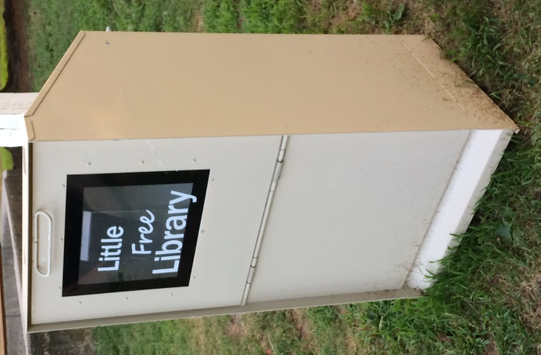
Entries are due by May 15th. Submit entries either electronically to snaprov@gmail.com or by post to:
Summit Neighborhood Association
Box 41092
Providence RI 02940
Good Luck and we look forward to seeing all the talented ideas!

