Background
- (take from articles/report below with plain facts/timeline)
- City website with docs: https://pawtucketri.com/news/city-pawtucket-national-parks-conversion-documents
- Article: https://www.providencejournal.com/story/opinion/columns/2023/12/03/for-the-families-who-live-in-this-city-neighborhood-morley-field-was-an-oasis/71656393007/

Compliance and Stewardship (C&S) Form
- Misleading to not include label of the river on the parcel maps
- Confusion and lack of transparency in maps (labeling McCoy Field Map X and providing no context of whether the parcels shown are kept, converted, or replacement)
Appendix A: Narrative
- The report states, “Morley Field is bordered to the west by Interstate 95, to the east by a vacant mill complex…” which is incorrect. The Field is bordered by the Moshassuck River, and then to the wests of that, Interstate 95.
- The report states, “The Pawtucket Parks and Recreation Director has reported that there have been no permit applications for any active recreation/league use for over a year.” This is misleading, as visitors have been prohibited due to a security fence.
- We do not deny that a new recreational opportunity at Riverside Park would benefit the City’s residents, but protecting a portion of a large, existing open space does not adequately make up for the loss of a park in a dense urban environment providing open space access to those that otherwise have nothing.
- Similarly, we do not deny that improvements and investment to Morley Field would be a benefit, but again – not through losing over half the park.
- The report also neglects to mention why Morley Field would be converted – it is my understanding that this space would be used to create a new parking area. It is incomprehensible how this conversion to increase impervious surfaces, runoff, air pollution, and water pollution would provide the best and highest use for this land which is already serving as critical access to green and blue spaces for an environmental justice neighborhood in an urban context with few alternatives.

Appendix B: Social Equity Discussion
- Read appendix & provide specific comments/notes
- Neighborhood access to additional open space other than this parcel is extremely limited.
- This is in a priority Environmental Justice area, as determined by EPA, as shown through NBEP’s EJ Map (Block Group: 440070164003).

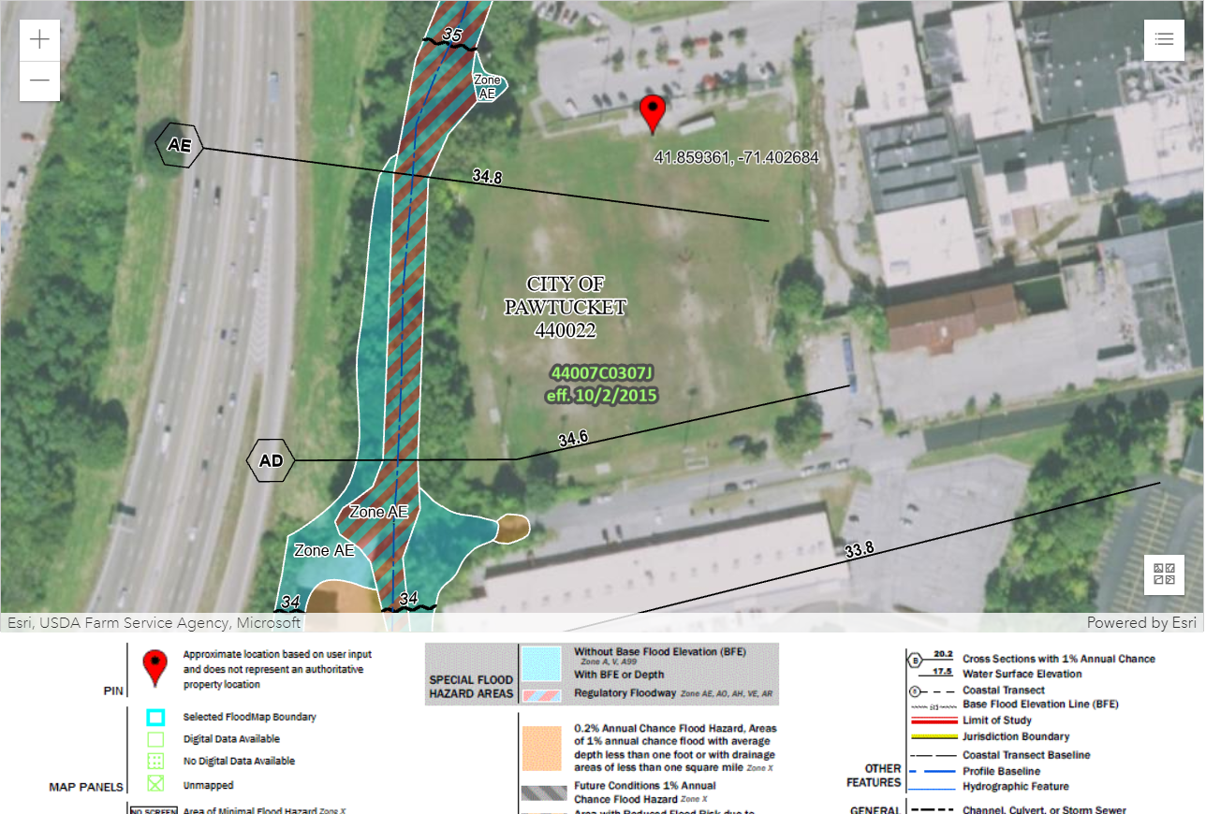

- This is in a priority Environmental Justice area, as determined by EPA, as shown through NBEP’s EJ Map (Block Group: 440070164003).
- It is a beloved area for the local neighborhood to exercise, experience nature, and play baseball. Visitors were prevented from visiting in 2020 due to COVID, and then by the fence that was erected. Studies show (link to Blue Mind; link to EPA report) that all people need access to water and blue and green spaces to reduce stress and anxiety – especially in environmental justice areas that have higher burdens.
- Tribal consultation included the Pequot – not local tribes such as the Narragansett.
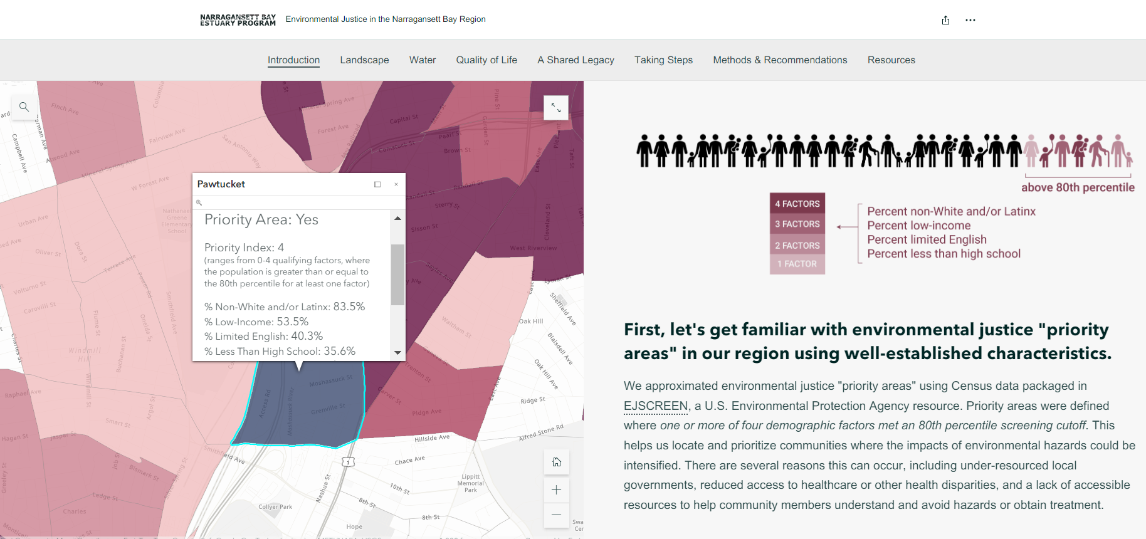

Appendix C: Morley Field Environmental Review
- Read appendix & provide specific comments/notes
- This parcel is along the Moshassuck River with an associated floodplain and floodway. It should not be developed with impervious cover and an increased opportunity for polluted runoff to enter the river and in turn the Narragansett Bay. Instead, this area should remain as open space and provide infiltration for the Moshassuck. If any changes are proposed, they should include more grasses & trees, as is the heat of the goal of the LWCF.

Conclusion:
- Combine above/revise/elaborate
- Do not support conversion
- It is incomprehensible how this conversion to increase impervious surfaces, runoff, air pollution, and water pollution would provide the best and highest use for this land which is already serving as critical access to green and blue spaces for an environmental justice neighborhood in an urban context with few alternatives.
- Against LWCF goals
- Does not meet social equity goals (EJ, access, dispersed SW mgmt/infiltration opportunity)
- Does not meet enviro goals (WQ, air quality, floodplain mgmt.)

